Woodland School:
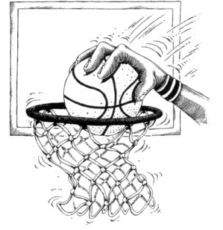
3rd Annual Basketball Game
Grades K-2 Staff and Parents

VS.

Grades 3-5 Staff and Parents

Who will win this year’s bragging rights???

Wednesday, March 22nd

Tickets ONLY$2.00

Game begins at 6:30 PM

Bake Sale by the Service Club

Come out and show your school spirit!!

Free Throw Contests
Food Truck arrives at 5:30!!

K-2 Team in Maroon, 3-5 in White

